MINISTRY OF EDUCATION AND SCIENCE OF THE REPUBLIC OF KAZAKHSTAN

INTERNATIONAL INFORMATION TECHNOLOGY UNIVERSITY

FACULTY OF INFORMATION TECHNOLOGIES

Department of Computer engineering and information security

COURSE PROJECT

Major 6B06110 – Software engineering

Discipline Web technologies

Topic: _______________Pharmacy_______________________

|  |  |  |
| --- | --- | --- |
| STUDENT(S): | ITSE-1906  Kabyl Dauren  (group and student name) | _____________  (signature) |
| SUPERVISOR: | Assistant-professor  Mukazhanov N.K.  (position, name) | _____________  (signature) |

Almaty 2021

# **Content**

Introduction_______________________________________________________3

Main part_________________________________________________________4

* Theoretical part_______________________________________________4
* Design______________________________________________________5
* Implementation (creation of website)______________________________7

Conclusion_______________________________________________________10

References_______________________________________________________11

# **Introduction**

My project is a pharmacy website where visitors can order medicines, get health advice, or contact us for help finding medicines.

The website Interface is based on HTML, CSS, Bootstrap.

The website Back-end is based on

The used server is

Link to github repository:

<https://github.com/diikiin/Web-project>

**Main part**

***Theoretical part***

The definition of HTML is **HyperText Markup Language**.

* *HyperText* is the method by which you move around on the web — by clicking on special text called **hyperlinks** which bring you to the next page. The fact that it is *hyper* just means it is not linear — i.e. you can go to any place on the Internet whenever you want by clicking on links — there is no set order to do things in.
* *Markup* is what **HTML tags** do to the text inside them. They mark it as a certain type of text (*italicised* text, for example).
* HTML is a *Language*, as it has code-words and syntax like any other language.

What is **CSS**?

* CSS stands for Cascading Style Sheets
* CSS describes how HTML elements are to be displayed on screen, paper, or in other media
* CSS saves a lot of work. It can control the layout of multiple web pages all at once
* External stylesheets are stored in CSS files

**Bootstrap** is a powerful toolkit - a collection of HTML, CSS, and JavaScript tools for creating and building web pages and web applications. It is a free and opensource project, hosted on GitHub, and originally created by (and for) Twitter.

***Design:***

MVC is an acronym for ‘Model View Controller’. It represents architecture developers adopt when building applications. With the MVC architecture, we look at the application structure with regards to how the data flow of our application works

MVC is a software architecture…that separates domain/application/business…logic from the rest of the user interface. It does this by separating the application into three parts: the model, the view, and the controller.

The model manages fundamental behaviors and data of the application. It can respond to requests for information, respond to instructions to change the state of its information, and even notify observers in event-driven systems when information changes. This could be a database or any number of data structures or storage systems. In short, it is the data and data-management of the application.

The view effectively provides the user interface element of the application. It’ll render data from the model into a form that is suitable for the user interface.

The controller receives user input and makes calls to model objects and the view to perform appropriate actions.

***Implementation (creation of website):***

Home page

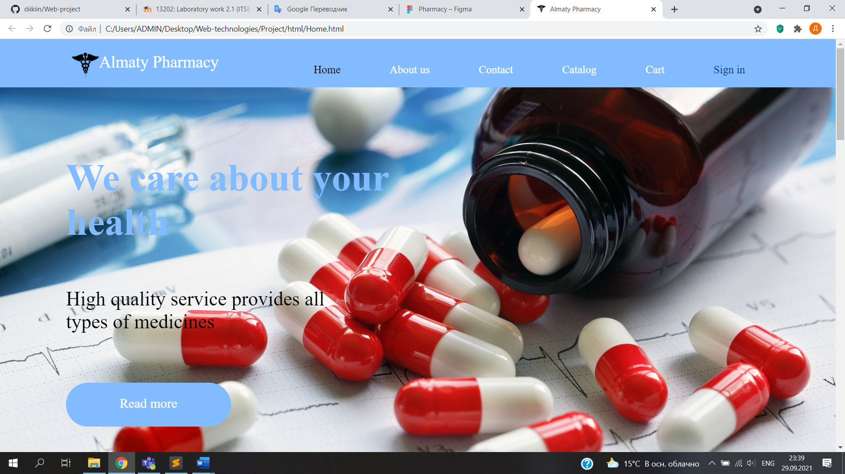

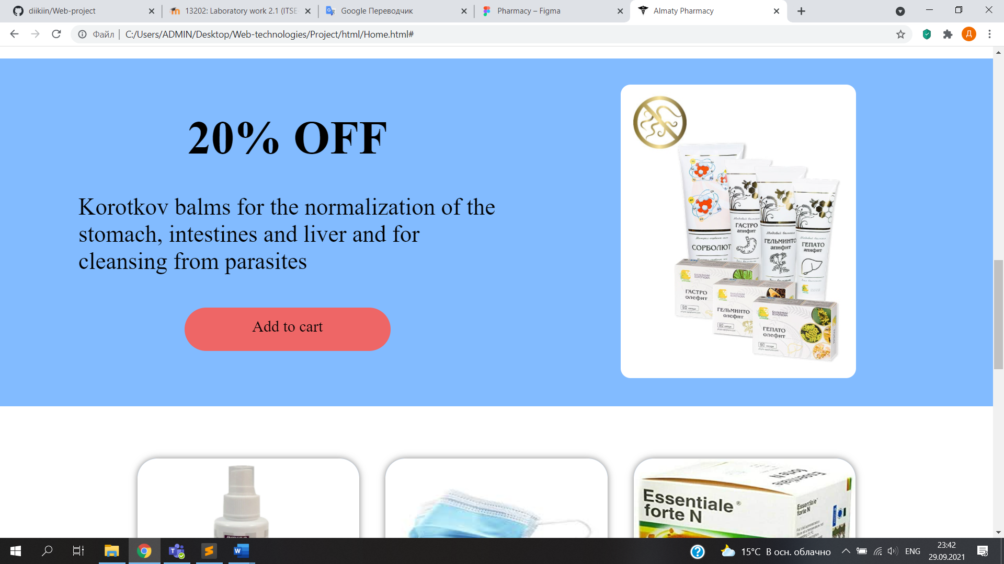

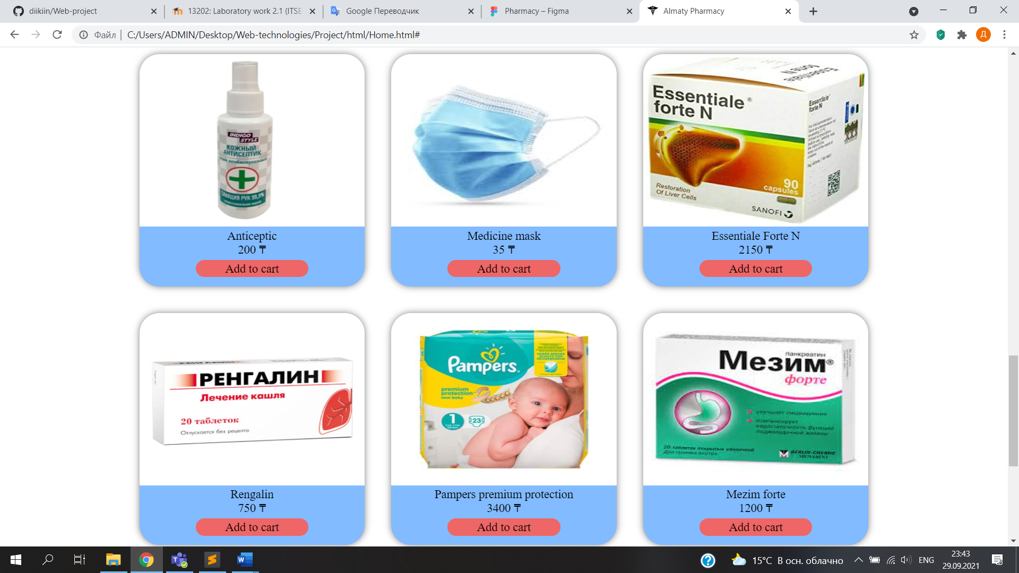

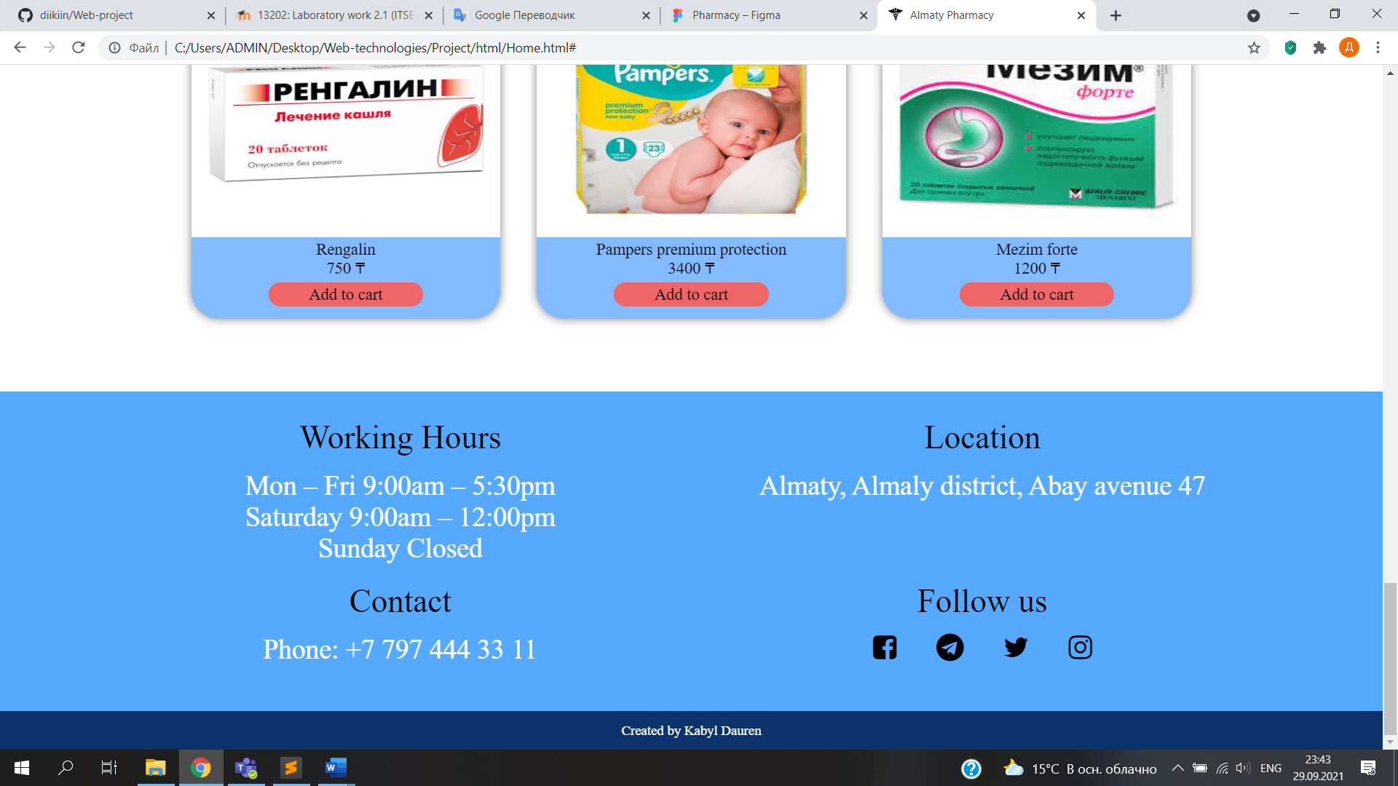

Contact page

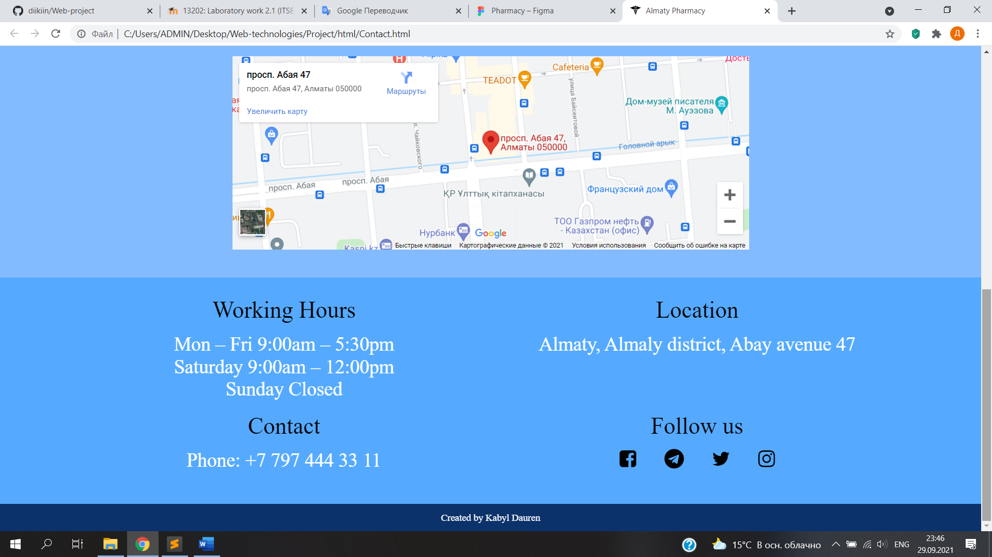

**Conclusion**

The Pharmacy features:

**References**

1. <https://www.yourhtmlsource.com/starthere/whatishtml.html>
2. <https://www.w3schools.com/css/css_intro.asp>
3. <https://www.toptal.com/front-end/what-is-bootstrap-a-short-tutorial-on-the-what-why-and-how>
4. <https://nicepage.com/html5-template/preview/pharmacy-and-medicine-16713?device=desktop>
5. <https://centralpharmacync.com/>
6. <https://lloydspharmacy.com/>
7. <https://www.walgreens.com/>